**Chat Feature in Mendix Code Documentation**

**Description:**

Chatting is a method of using technology to bring people together despite geographical barriers. Hence we implemented module that is reusable and can be used to implement chat features in any application of mendix. In This module we have implemented a user story based on our daily chat experience on WhatsApp web and teams web using mendix.

**Typical Use-case Scenario:**

We may use this component in following ways:

* For implementation of communication between 2 parties.
* Document upload and image upload feature has been implemented and can be used directly in any application.

**Prerequisites**:

N/A

**Features and Limitation:**

We created this web version of Chat module in which we implemented various functionalities such as:

* + Sending and receiving messages live chat
  + Sharing file documents and images
  + Profile Update
  + Profile image change

**Limitations:**

* Not compatible for natives Apps
* No group chat currently
* no push notification

**Installation**:

Download Chat module from marketplace. After downloading the Chat module do the following steps:

1. Create “many to one” association between Account and Profile entity. As shown in image below:

1. Add “Chat_Web” page from “Pages ” folder to navigation.
2. Check if any error related to layout , resolve them as per mendix version you are using.

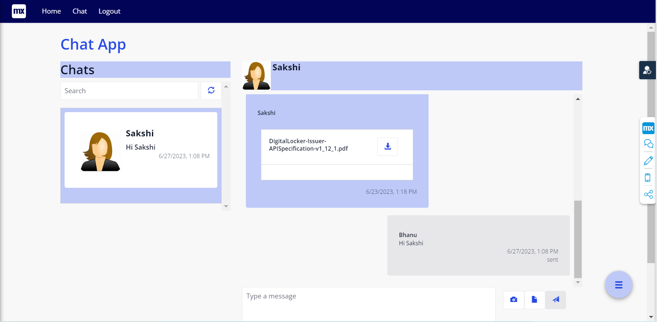

**Chat View page:** It’s the landing page and it shows list if chats on left side and on right side the chat window for selected user is opened.

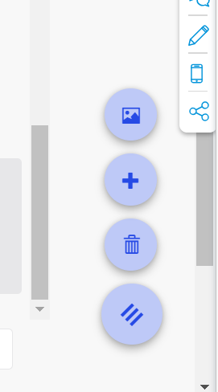

Toggle Action Button: On click of which we may proceed with delete chat, new chat and change profile.

List of user displayed and from here user may select and start with chat

New chat started

Action buttons on right are for Image upload ,Document upload and send message respectively

**Configuration: NA**

**Category: Module**

**Subcategory: All**

**Visibility: Public Marketplace**

**Studio Pro Version: 9.1.0**